Week 3 Deliverable — Paper Annotation Worksheet
QueryGenie: A Self-Correcting Natural Language to SQL Interface
Team 21 · 2320090050 N V V S S Jayakanth Kamisetti · 2320090009 Bodupally Narendar · Supervisor: M Parameswar
SOP requirement for Week 3: “Deep technical read — annotate the paper section-by-section. Identify: inputs, outputs, key equations, hyperparameters.” Deliverable: annotated PDF + algorithm flowchart.
Anchor paper: CodeS — Towards Building Open-source Language Models for Text-to-SQL, SIGMOD 2024. https://arxiv.org/abs/2402.16347
How to use this worksheet: the middle column contains facts already verified from the paper abstract and the official repository. The shaded right-hand column is what you must complete while reading the PDF. Do not guess any value — if you cannot find it, write “not stated in paper”. Fabricating a figure is an academic-misconduct offence under the SOP.

1. Problem, Inputs and Outputs
Item | What we already know (verified) | Fill in from the paper
Problem addressed | SOTA text-to-SQL relies on closed-source LLMs (GPT-4), causing unclear architectures, data-privacy risk and high inference cost. Also targets schema linking and rapid domain adaptation. | Section / page where stated: ______
Input | A natural language question + the target database (schema, and cell values indexed with BM25). | Exact input representation used: ______
Output | An executable SQL query for the target database. | Post-processing applied, if any: ______
Task formulation | Autoregressive sequence generation conditioned on a constructed prompt. | How is the prompt tokenised / truncated? ______

2. Model and Architecture
Item | What we already know (verified) | Fill in from the paper
Base model | StarCoder (code LLM). | Exact base checkpoint named: ______
Model scales | 1B, 3B, 7B, 15B — all released publicly on Hugging Face. | Which scale reports the headline result? ______
Pre-training method | Incremental pre-training on a curated SQL-centric corpus. | Corpus size / token count: ______
Schema handling | A schema item classifier (“schema filter”) ranks and prunes tables and columns. | Its architecture and size: ______
Value linking | BM25 index built per database over cell contents (build_contents_index.py). | How are matched values inserted into the prompt? ______
Domain adaptation | Bi-directional data augmentation. | What are the two directions? ______

3. Key Equations
The abstract does not state the paper’s equations. Record them here as you read — for each, note the equation number, what each symbol means, and where it is used in the pipeline.
Item | What we already know (verified) | Fill in from the paper
Training objective | Not verifiable from the abstract — read Section 3. | Equation no. ____ Form: ______________
Schema-filter objective | The classifier is trained separately (train_sic.sh in the repo). | Equation no. ____ Loss used: __________
Decoding / scoring | Autoregressive decoding; beam search used in the repo scripts. | Equation no. ____ Scoring rule: ________
Any other equation | — | Equation no. ____ Purpose: ____________

4. Hyperparameters
Values below marked “repo” were read from the official repository, not the paper. Confirm each against the paper and record any disagreement — a mismatch between repo and paper is itself a finding worth reporting.
Item | What we already know (verified) | Fill in from the paper
Optimizer / LR | Not stated in the abstract. | Paper value: ______
Global batch size | repo: 8 GPUs × batch 4 × grad-accum 4 = 128 (training). | Paper value: ______
Precision | repo: bf16 mixed precision (accelerate config). | Paper value: ______
Parallelism | repo: DeepSpeed ZeRO stage 2 via Hugging Face Accelerate. | Paper value: ______
Epochs / steps | Not stated in the abstract. | Paper value: ______
Max sequence length | Not stated in the abstract. | Paper value: ______
Beam width (inference) | Set inside run_sft_evaluations.sh — read the script. | Paper value: ______
Pre-training batch | repo: global batch of exactly 4,194,304 tokens. | Paper value: ______

5. Datasets and Reported Results
Record the reported numbers for the exact configuration you intend to reproduce (CodeS-1B on Spider dev). This is the figure your reproduction will be measured against under the ±5–10% tolerance, so copy it precisely and note the table and row it came from.
Item | What we already know (verified) | Fill in from the paper
Benchmarks used | Spider, BIRD, Spider-DK, Spider-Syn, Spider-Realistic, Dr.Spider. | Which table reports Spider dev? ______
Metrics | Exact-set Match (EM), Execution Accuracy (EX). | Which is the headline metric? ______
CodeS-1B on Spider dev | TBD — must be read from the paper. | EX: ______ EM: ______ (Table ___)
Best reported scale | Paper claims new SOTA on nearly all benchmarks. | Scale: ______ EX: ______ EM: ______
Baselines compared | Not enumerated in the abstract. | List: ______
Ablations in the paper | Schema filter is a separable component (released standalone). | Does the paper ablate it? Result: ______

6. Reproduction Notes
- Which evaluation script corresponds to the number you are targeting — run_sft_evaluations.sh or run_few_shot_evaluations.sh?
- Does the reported figure use the schema filter? If yes, sic_ckpts is required.
- Record any hyperparameter you are forced to change (batch size, beam width, precision) and why — these become documented deviations.
- The authors warn that newer transformers versions shift inference results slightly. If you see a small gap, this is a legitimate cause to cite, not a defect to conceal.

7. Algorithm / Architecture Flowchart
Reconstructed from the paper abstract and the official repository structure. Verify against Figure 1 and Section 3 of the paper and correct it before submission.
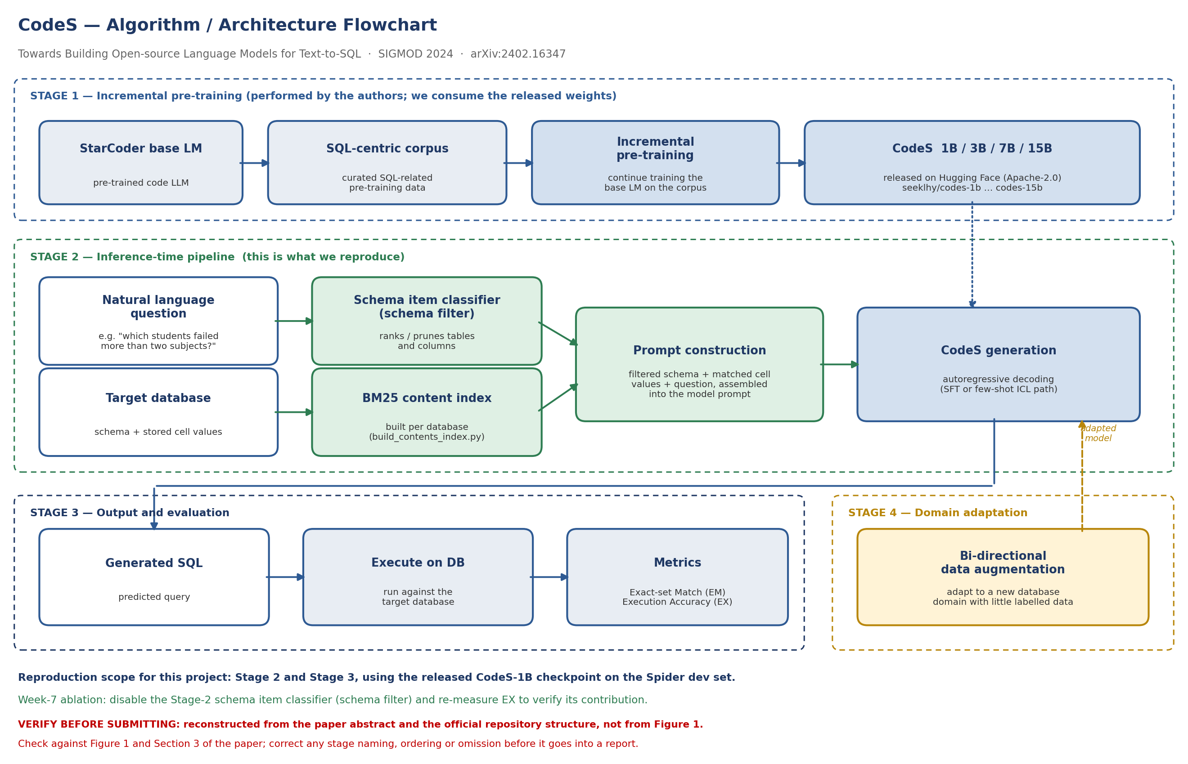

8. Section-by-Section Reading Log
Complete one line per section as you read. This is the evidence that the annotation was done systematically.
Section | Main claim / contribution | Questions or doubts raised
1. Introduction
2. Related Work
3. Method
4. Experimental Setup
5. Results
6. Ablation / Analysis
7. Conclusion
Sign-off: this worksheet, the annotated PDF and the flowchart together constitute the Week 3 deliverable. Discuss with the supervisor before the weekly report is submitted.

